THE HEALTH ALLIANCE FOR PRUDENT PRESCRIPTION AND YIELD OF ANTIBIOTICS FROM A PATIENT-CENTRED PERSPECTIVE
Training healthcare professionals and empowering the patient

The HAPPY PATIENT project was formed
as a response from the European Commission to addressthe increase of antimicrobial resistance.

ANTIMICROBIAL RESISTANCE: A GROWING DANGER
The emergence of resistant bacteria has raised fears of a return to the pre-antibiotic era.
Estimations show that it will be the first cause of death in 2050.

Antimicrobial resistance (AMR) is a growing problem threatening societal development and human health.

More than 50% of the episodes of pharyngitis, acute rhinosinusitis, and acute bronchitis are treated with antibacterial agents, and most of this prescribing is deemed to be unnecessary.

HAPPY PATIENT AIMS TO CURB THE PROBLEM
Reducing the unnecessary antibiotic prescribing is the most effective measure against AMR. These are the actions suggested by HAPPY PATIENT:
Propose an innovative patient-centred approach which implies the involvement of all health care-providers acting as main point of contact for the management of community- acquired infections.
We will help practitioners to reevaluate their prescribing habits and patients to change their expectations.
Healthcare professionals will be enabled to evaluate their own practices.
Healthcare professionals will be given assistance in managing their communications with patients in a positive way.
Pharmacists will emphasize their role as gatekeepers to the safe use of antibiotics.
We will ask previously identified stakeholders to re-evaluate well-established practices in order to reduce innapropiate antibiotic prescription.

The content of this leaflet represents the views of the author only and is his/her sole responsibility; it cannot be considered to reflect the views of the European Commission and/or the Consumers, Health, Agriculture and Food Executive Agency (CHAFEA) or any other body of the European Union. The European Commission and the Agency do not accept any responsibility for use that may be made of the information it contains

HAPPY PATIENT GOALS

ENABLE
a significant increase in the impact of the EU’s guidelines on the prudent use of antimicrobials

SET UP TO REDUCE BY 40%
INVOLVE ALL
health care-providers acting as the main point of contact for the management of community-acquired
infections

inappropiate prescription
of antibiotics

FOCUS ON
common community-acquired infections, especially respiratory and urinary tract infections

BUILD UPON EVIDENCE
and propose an innovative
patient-centred approach

4 HEALTH PROFESSIONAL TARGETED SETTINGS

Primary care: GPs and nurses
GPs prescribe the majority of all antimicrobial agents prescribed, approximately 80% of all the antibiotics.

Secondary Care: Hospitals and Out-of-Hours (OoH) service GPs and clinicians
This is an important source of antibiotics prescribed for all types of community-acquired infections.

Tertiary Care: Nursing Home professionals
There is solid evidence that antibiotics are heavily prescribed in nursing homes for suspected urinary tract infections. Approximately 10% of residents are treated every day with an antibiotic in Spain.
Pharmacies: Pharmacists
Pharmacists play a crucial role in directly reinforcing messages about appropriate use when handing antibiotics to patients or carers and are amongst the groups most trusted to convey such messages.

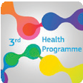
Grant Agreement number 900024

This project was funded by the European Union’s Health Programm (2014-2020)

The content of this leaflet represents the views of the author only and is his/her sole responsibility; it cannot be considered to reflect the views of the European Commission and/or the Consumers, Health, Agriculture and Food Executive Agency (CHAFEA) or any other body of the European Union. The European Commission and the Agency do not accept any responsibility for use that may be made of the information it contains

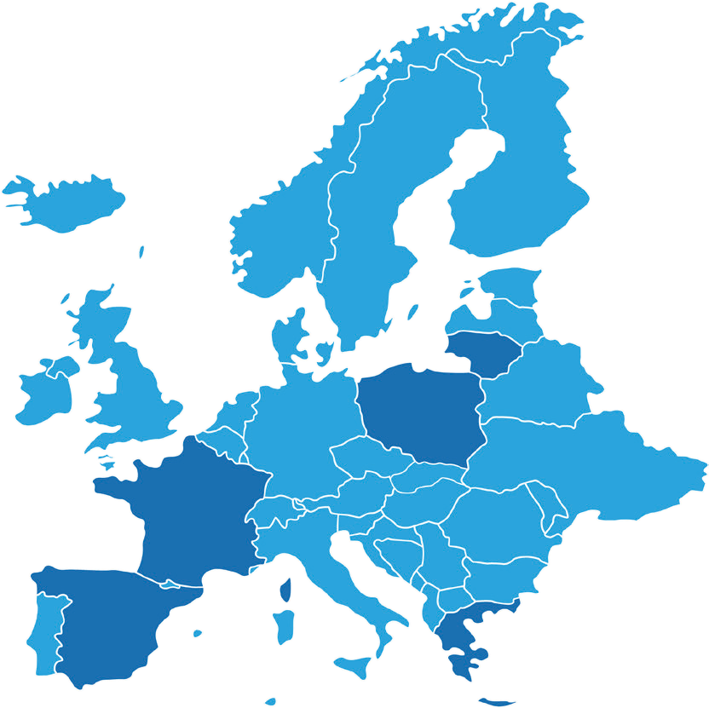
HAPPY PATIENT sets out a significant move forward from theory to practice in relation to promoting responsible stewardship amongst both healthcare professionals and patients.
5 TARGETED EUROPEAN COUNTRIES
LITHUANIA
Spain, France, Lithuania,
Poland and Greece have been targeted for the HAPPY PATIENT project.
All target countries have diverse health systems, incomes and
level of antimicrobial.
POLAND
FRANCE
GREECE
Antibiotic consumption map in Europe

Lower in
Nordic countries

Higher in
Southern European countries
SPAIN

THE APO METHODOLOGY
The APO method stands for:
AUDIT PROJECT ODENSE.
It is a multifaceted intervention based on state-of-the-art procedures and information to change practice behaviour and patients’ perceptions about antibiotic use and AMR.

BEFORE THE INTERVENTION:
Health care professionals will be asked to participate in the project, encompassing a first registration, the intervention and a second final registration.
A minimum number of 25 professionals will be recruited in each country for the different healthcare professional groups and will collect data on the diagnostic process and management of community-acquired infections during a first audit registration in February 2022.

THE APO METHODOLOGY

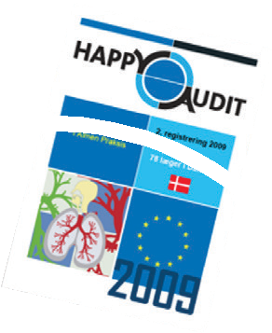
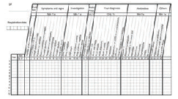
Analyses & interpretatio
n
Follow up meeting
Public campaign
Adaptation of EU guidelines Obtain approvals
Fit APO-template Invite participants Sign-up participants Pilot testing
Make registration guide Distribute materials
FINAL REPORT
First registration
FINAL MEETING
PUBLICATIONS

ollective & individual edback reports
C
fe

Second registration

Patient information materials

Peer-to-peer feedback

Presentation of results Lecture by local expert

INTERVENTION FOR PROFESSIONALS AND PATIENTS:
The results of the first audit registration will be presented at meetings for health care professionals and reflections and initiatives to improve quality problems will be discussed.
Experts in antibiotic prescribing and other relevant resource persons will also be consulted.

AFTER THE INTERVENTION:
In follow-up meetings feedback and identified potential quality problems from the first registration will be given.
Results will be discussed at follow-up meetings in each of the different areas and will be run by the local coordinators of the study.
1 to 3 months before the second registration, to take place in February 2023, the participating professionals will receive a training course on the appropriate use of antibiotics for common community-acquired infections.
Brochures and handouts to patients about prudent use of antibiotics Posters for waiting rooms, focusing on the appropriate use of antibiotics
Enhancement of communication skills to be used during the consultation with patients with community-acquired infections

Grant Agreement number 900024

This project was funded by the European Union’s Health Programm (2014-2020)

AN INTERNATIONAL CONSORTIUM

The content of this leaflet represents the views of the author only and is his/her sole responsibility; it cannot be considered to reflect the views of the European Commission and/or the Consumers, Health, Agriculture and Food Executive Agency (CHAFEA) or any other body of the European Union. The European Commission and the Agency do not accept any responsibility for use that may be made of the information it contains
15 partners & 2 associated entities.
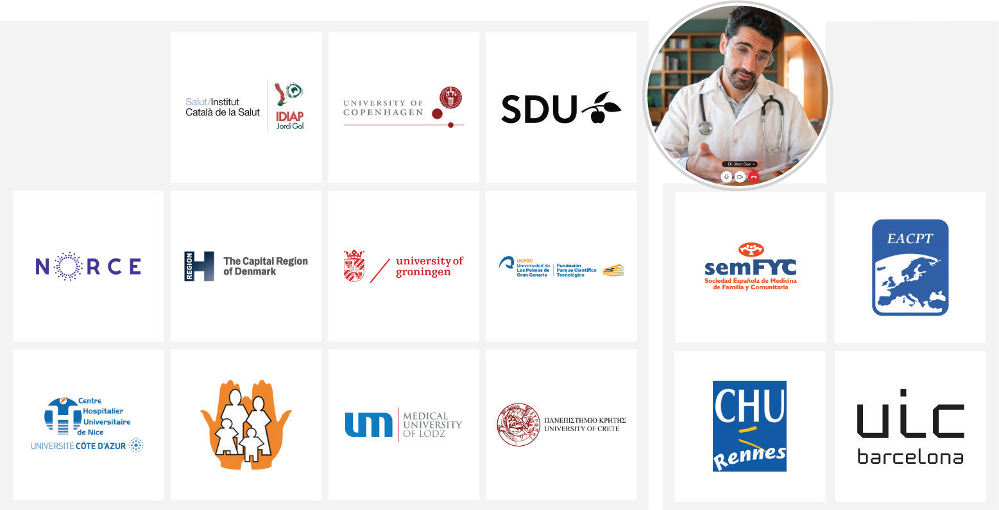
Academia, research, and clinical practice
Professional umbrella organizations

IMPACT
The project’s work programme is designed to provide immediate impact.
The HAPPY PATIENT project will help understanding and implement interventions regarding appropriate antimicrobial prescription and usage for human consumption.
The project will focus on the interaction between healthcare professionals and patients.
The reduction in antimicrobial use will lead to a reduction of antimicrobial resistance both in the community and in the individuals.
More HAPPY PATIENTs are to be seen in Europe within the next few years..

WHERE DO I FIND HAPPY PATIENT?

www.happypatient.eu

TWITTER @HAPPY_PATIENT

LINKEDIN HAPPY PATIENT

INSTAGRAM @happy_patient_eu

FACEBOOK HappyPatientEU

WHEN WILL THE HAPPY PATIENT TAKE PLACE?
Over 36 months: 2021 - 2023

For more information, please visit www.happypatient.eu

HAPPY PATIENT

Grant Agreement number 900024

This project was funded by the European Union’s Health Programm (2014-2020)

Grant Agreement number 900024

This project was funded by the European Union’s Health Programme (2014-2020)

www.happypatient.eu

