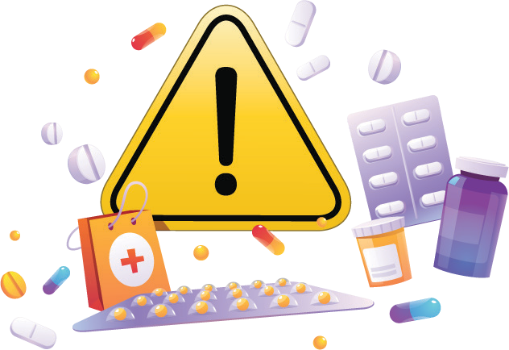
Infections with antibiotic-resistant bacteria are associated with:
an increased number of visits to health care providers
more hospital admissions higher mortality
higher economic expenditure
The content of this leaflet represents the views of the author only and is his/her sole responsibility; it cannot be considered to reflect the views of the European Commission and/or the Consumers, Health, Agriculture and Food Executive Agency (CHAFEA) or any other body of the European Union. The European Commission and the Agency do not accept any responsibility for use that may be made of the information it contains

THE HEALTH ALLIANCE FOR PRUDENT PRESCRIPTION AND YIELD OF ANTIBIOTICS FROM A PATIENT-CENTRED PERSPECTIVE

The HAPPY PATIENT project was formed as a response from the European Commission to address the increase of antimicrobial resistance.
Training healthcare professionals and empowering the patient

WHY IS AMR SO IMPORTANT?

Antimicrobial Resistance (AMR) is a phenomenon by which a bacterium becomes resistant to the activity of an antimicrobial drug.
Some studies show that lack of action today may cause about 10 million deaths per year by 2050. AMR is a growing problem threatening societal development and human health.

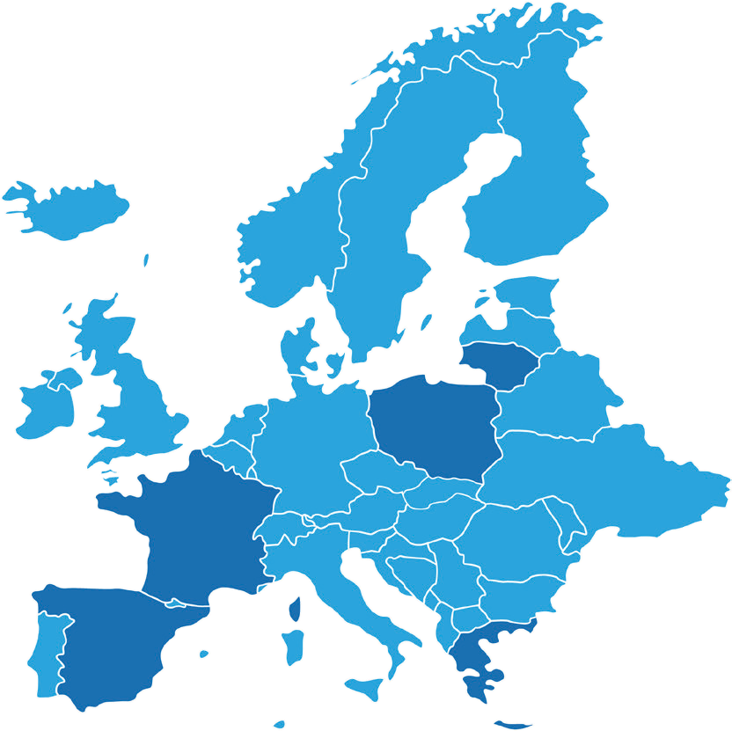
HOW CAN YOU FIGHT IT?
WHERE DO WE TARGET AMR?
LITHUANIA
Spain, France, Lithuania,
Poland and Greece
have been targeted for the HAPPY PATIENT project. They have diverse health systems, incomes and level of antimicrobial medicines consumption
POLAND
FRANCE
GREECE

Higher in
Southern European countries

Lower in
Nordic countries
Antibiotic consumption map in Europe
SPAIN

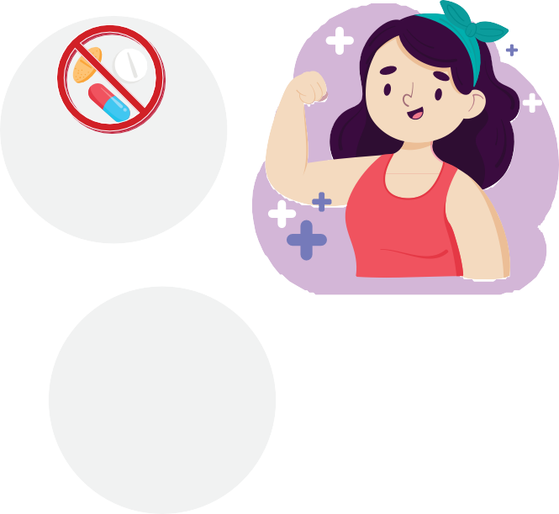
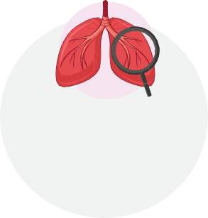
Antibiotics cannot
cure every
single disease
Don’t take antibiotics if
your doctor didn’t
prescribe
them to you

Most cold and flu symptoms
are best treated at home
with paracetamol
or ibuprofen, plenty
of fluids and sleep
Be aware that antibiotics
are not effective against
viral infections

Most common respiratory
tract infections, such as
the common cold and the
flu, are viral and cannot
be treated with
antibiotics

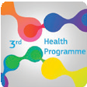
Grant Agreement number 900024
This project was funded by the European Union’s Health Programm (2014-2020)

WHAT IS HAPPY PATIENT?
HAPPY PATIENT is a European Project that aims to reduce unnecessary antibiotic prescription in Europe.

OUR GOALS

REDUCE
antibiotic consumption by implementing a successful strategy

DECREASE
the unnecessary prescription
of antibiotics

BY 40%

HELP YOU!
to get more involved in your own health and participate in your health
decisions

BUILD
a new innovative
patient-centered dynamic

HOW IS HAPPY PATIENT AIMING TO ACHIEVE IN THESE GOALS?
HAPPY PATIENT will implement a patient-centred approach. We will engage Health Care Professionals, who will act as the first points of contact with the healthcare system and will be responsible for the management of community-acquired infections..
The Health Care Professionals to be involved in the HAPPY PATIENT project are:
Providers of primary health care services i.e. General Practitioners (GPs), nurses, and dentists Clinicians in Out-of-Hour (OOH) Services
Nursing home clinicians Pharmacists

The APO method will give to the HCPs the means to think, reflect and improve their actions when facing a certain situation, and this will help reduce the unnecessary prescriptions of antibiotics.

The content of this leaflet represents the views of the author only and is his/her sole responsibility; it cannot be considered to reflect the views of the European Commission and/or the Consumers, Health, Agriculture and Food Executive Agency (CHAFEA) or any other body of the European Union. The European Commission and the Agency do not accept any responsibility for use that may be made of the information it contains

AN INTERNATIONAL CONSORTIUM
15 partners & 2 associated entities.
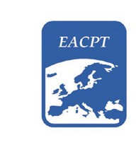
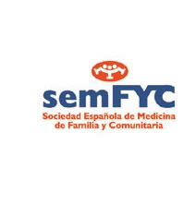

Academia, research, and clinical practice

Professional umbrella organizations

WHERE DO I FIND HAPPY PATIENT?

www.happypatient.eu @HAPPY_PATIENT HAPPY PATIENT @happy_patient_eu HappyPatientEU
WHEN WILL THE HAPPY PATIENT TAKE PLACE?

Over 36 months: 2021 - 2023
The reduction in antimicrobial use will lead to a reduction of antimicrobial resistance both in the community and in the individuals.

For more information, please visit www.happypatient.eu

Grant Agreement number 900024

This project was funded by the European Union’s Health Programm (2014-2020)

