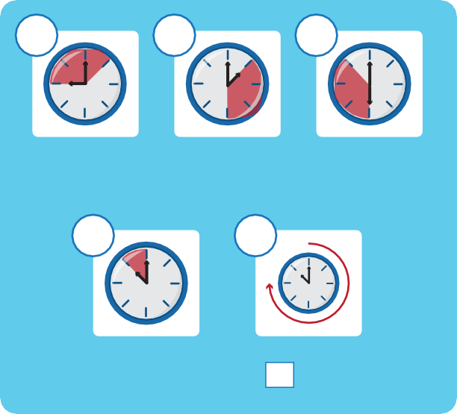
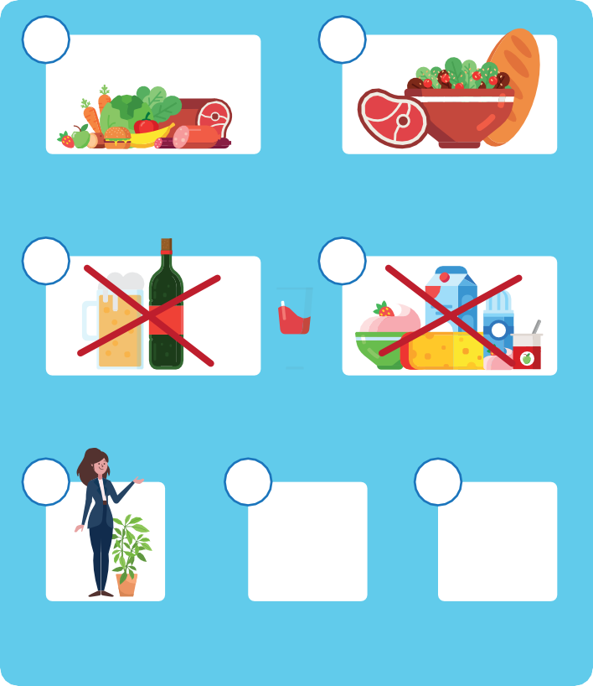
HAPPY PATIENT
What you need to know if
you have been prescribed an antibiotic

When to take your antibiotic: How to take your antibiotic:

1 h / 2-3 h

in the morning
in the afternoon
in the evening
At least 1 hour before or 2-3 hours after food
With food

Shortly before sleeping
Every hours
Do not take with alcohol
Do not take with dairy products

Duration of antibiotic treatment:
You should stop your antibiotic treatment after days.

Possible side effects include:

In an upright position

In a sitting down position

Avoid sun exposure

Diarrhoea, nausea and vomiting, abdominal pain, loss of appetite, skin rashes, headache/dizziness, fungal infections (candida).

Possible food and drug interactions:
Combining the use of antibiotics with other medications or alcohol can modify the efficacy and increase the risk of adverse reactions.
Ask your pharmacist or healthcare provider for any potential food and drug interactions.

i
Most side effects are mild and temporary.
If side effects become severe, you should contact a healthcare professional

Please remember:
Take the prescribed antibiotic treatment according to the prescription from the doctor.
Don’t share antibiotics with your family members, friends, or animals. Return any unused antibiotics to the pharmacy.
Contact your healthcare provider if your symptoms get worse.
Inform your healthcare provider and/or your pharmacist about any allergies you may have.
If you are pregnant, breastfeeding or planning to get pregnant,
make sure that your healthcare provider and/or pharmacist is aware of it, to ensure safe use of the medication.

When to contact a pharmacist:
For any questions about the medication you use.
For information about relief of symptoms or side effects.
If you are unsure about any of the information you have received. If you are unsure about how or when to take your medication.

HAPPY PATIENT
The content of this leaflet represents the views of the author only and is his/her sole responsibility; it cannot be considered to reflect the views of the European Commission and/or the Health and Digital Executive Agency (HaDEA), replacing the former CHAFEA since 01 April 2021, or any other body of the European Union. The European Commission and the Agency do not accept any responsibility for use that may be made of the information it contains.

