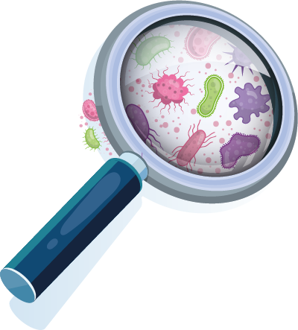

Viruses or bacteria
What caused your infection?

Infection

Most people
get better by
Virus

Bacteria
Virus or
bacteria
Common cause

Are antibiotics
recommended?

COVID -19

Common cold
Flu

Laryngitis

Lar Tonsilitis / Pharyngitis yngitis

Acute bronchitis
Sinusitis

Sore throat

Ear infection
throat

Exacerbation of COPD
throat

Pneumonia

Urinary tract infection

1-3 weeks

1-2 weeks
2-3 weeks

1 week

1 week

3 weeks

2 weeks

1 week

1 week

1-2 weeks

1-2 weeks

2-3 days

NO
NO
NO
NO
NO
NO
SOMETIMES
SOMETIMES
SOMETIMES
SOMETIMES
YES
YES

Antibiotics are only needed to treat certain infections caused by bacteria. Viral infections should not be treated with antibiotics.
Use of antibiotics can lead to antimicrobial resistance.
This means that antibiotics become ineffective and infections become increasingly difficult to treat.

The content of this leaflet represents the views of the author only and is his/her sole responsibility; it cannot be considered to reflect the views of the European Commission and/or the Consumers, Health, Agriculture and Food Executive Agency (CHAFEA) or any other body of the European Union.
The European Commission and the Agency do not accept any responsibility for use that may be made of the information it contains

