THE HEALTH ALLIANCE FOR PRUDENT PRESCRIPTION AND YIELD OF ANTIBIOTICS FROM A PATIENT-CENTRED PERSPECTIVE

HOW TO MANAGE YOUR COMMON INFECTION

WHAT ARE THE SYMPTOMS OF A COMMON INFECTION?

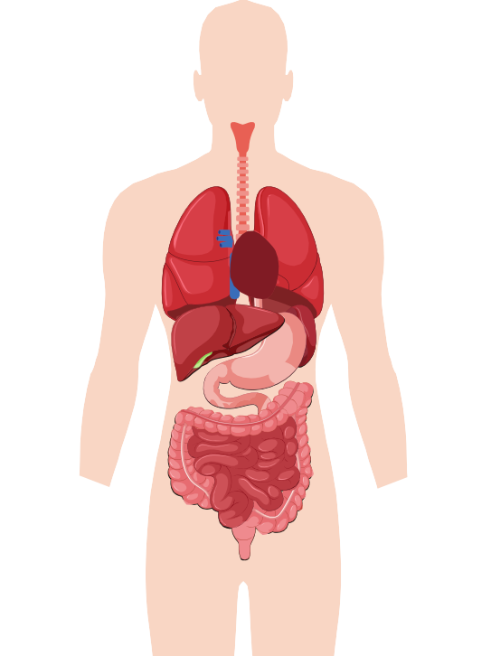
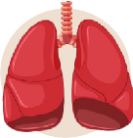
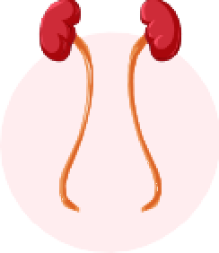
COVID-19 (~1-3 weeks)
Fever Cough Fatigue Headache
Loss of taste and/or smell Sore throat
Body aches
Difficulty of breathing /

Flu (~2-3 weeks)
Fever Shivering Muscle pain Sore throat Cough Headache Fatigue

Common cold (~1-2 weeks)
Runny nose Congestion Sneezing Cough Sore throat
Fever

shortness of breath

Ear infection (~1 week)
Ear pain
Potentially secretion
from the ear

Laryngitis, (~1 week)
Dysphonia Sore throat Dry cough

Tonsillitis, pharyngitis
(~1 week)
Fever Sore throat symptoms:
Pain while swallowing enlarged and painful glands

Urinary tract infection(~2-3 days)

Dysuria Frequency Urge
Tension over the bladder Bad smelling urine
Sinusitis (~2 weeks) Pain over sinus Cough
Nasal discharge Congestion

Acute bronchitis (~3 weeks)
Cough Colored sputum
Chest pain Fatigue Headache Muscle pain

Pneumonia(~1-2 weeks)
Dyspnea Tachypnoea Cough Fever Shivering Chest pain Fatigue

This project was funded by the European Union’s Health Programm (2014-2020)
WHAT CAN I DO TO RELIEF MY SYMPTOMS?

Rest as much as possible

Remember to drink a sufficient amount of fluids to avoid dehydration

For a sore throat: ice chips, throat lozenges or spray and pain relief, or gargle with salt water

For a congested nose: saline nasal spray
or drops

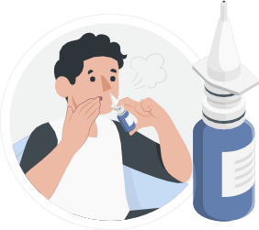
For coughs:
try cough syrup as recommended by your pharmacist

The content of this leaflet represents the views of the author only and is his/her sole responsibility; it cannot be considered to reflect the views of the European Commission and/or the Consumers, Health, Agriculture and Food Executive Agency (CHAFEA) or any other body of the European Union. The European Commission and the Agency do not accept any responsibility for use that may be made of the information it contains
39º

For high fever, shivering and pain relief: paracetamol

INFORMATION ABOUT THE USE OF ANTIBIOTICS AND ANTIMICROBIAL RESISTANCE
You do not usually need antibiotics,
unless symptoms of a bacterial infection
are severe. A healthcare professional
can advise you on this

Your body can normally fight off common infections on its own

Taking antibiotics when you
do not need to will make them
less effective in treating
infections in the future

Follow your healthcare provider’s advice on antibiotics

WHAT SYMPTOMS SHOULD I LOOK OUT FOR AND WHEN TO CONTACT A HEALTHCARE PROVIDER?
If your symptoms do not improve within the time indicated or get worse, or if you show any of the following symptoms, contact your healthcare provider.

Problems swallowing
Turning blue around the mouth Chest pain or tightness Difficulty breathing
New very fast or slow pulse oughing blood
Visible blood in urine Neck stiffness
Petechiae (small bleedings under the skin)

CALLING
(
(
(

Grant Agreement number 900024

This project was funded by the European Union’s Health Programm (2014-2020)

Grant Agreement number 900024

This project was funded by the European Union’s Health Programme (2014-2020)

The content of this leaflet represents the views of the author only and is his/her sole responsibility; it cannot be considered to reflect the views of the European Commission and/or the Consumers, Health, Agriculture and Food Executive Agen- cy (CHAFEA) or any other body of the European Union. The European Commission and the Agency do not accept any responsibility for use that may be made of the information it contains

www.happypatient.eu
www.happypatient.eu

