URINARY TRACT INFECTIONS

A leaflet for older adults and their families
A leaflet for older adults and their families

WHAT IS A URINARY TRACT INFECTION (UTI)?
A UTI occurs when bacteria enter the urinary tract and cause symptoms. The bacteria involved in a UTI come from your own gastrointestinal tract, where they normally exist.

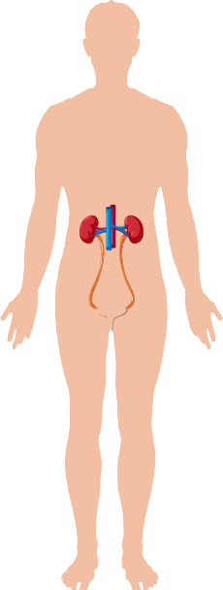
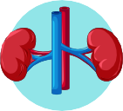

KIDNEYS
Kidneys make urine

URETER BLADDER
Bladder stores urine

URETHRA
Urethra takes urine out of the body

THE HEALTH ALLIANCE FOR PRUDENT PRESCRIPTION AND
YIELD OF ANTIBIOTICS FROM A PATIENT-CENTRED PERSPECTIVE

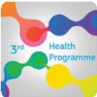

This project was funded by the European Union’s Health Programm (2014-2020)

WHAT ARE THE TYPICAL SYMPTOMS OF A UTI?

frequent urination or urge
Burning sensation or pain when urinating
potentially fever and blood in urine

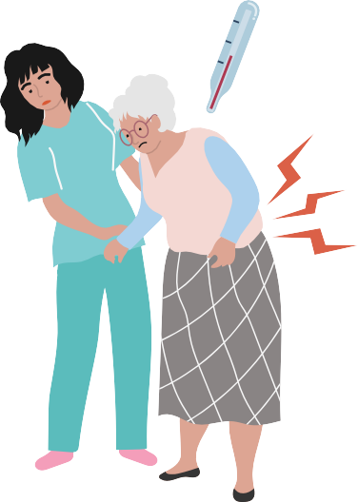

If you have some of these symptoms, you may have a UTI and you should contact
a nurse or a medical doctor.
WHAT ARE THE SYMPTOMS OF A SERIOUS INFECTION?

If the symptoms above are followed by symptoms below, it may be due to a possibly serious infection or complication and you should contact a healthcare professional urgently:

Back pain and fever

Confusion, drowsiness and slurred speech

The content of this leaflet represents the views of the author only and is his/her sole responsibility; it cannot be considered to reflect the views of the European Commission and/or the Consumers, Health, Agriculture and Food Executive Agency (CHAFEA) or any other body of the European Union. The European Commission and the Agency do not accept any responsibility for use that may be made of the information it contains

ANTIBIOTICS FOR UTIS: PROS AND CONS
1
Antibiotics can shorten the duration of symptoms and can be life saving for serious a UTI.

Antibiotics can come with side effects. Among the most common ones are rashes, vomiting, diarrhea, and increased risk of yeast infections.
2

Taking antibiotics increases the risk of resistant bacteria. Bacteria resistant to antibiotics do not respond well to treatment.
3
4
If your symptoms do not improve within a couple of days after starting antibiotics, contact your doctor/nurse.

WHAT CAN YOU DO TO PREVENT IT?

Wipe genitals from front to back after using the toilet to avoid that bacteria enter the urinary tract.

Change pads and clean genitals if soiled.

Keep the genital area clean and dry. Avoid using soap

Drink plenty of water.

Try to move around as much as possible

Grant Agreement number 900024

This project was funded by the European Union’s Health Programm (2014-2020)

www.happypatient.eu

Grant Agreement number 900024

This project was funded by the European Union’s Health Programme (2014-2020)

The content of this leaflet represents the views of the author only and is his/her sole responsibility; it cannot be considered to reflect the views of the European Commission and/or the Consumers, Health, Agriculture and Food Executive Agen- cy (CHAFEA) or any other body of the European Union. The European Commission and the Agency do not accept any responsibility for use that may be made of the information it contains

www.happypatient.eu

